

Facebook Instagram Twitter Linkedin

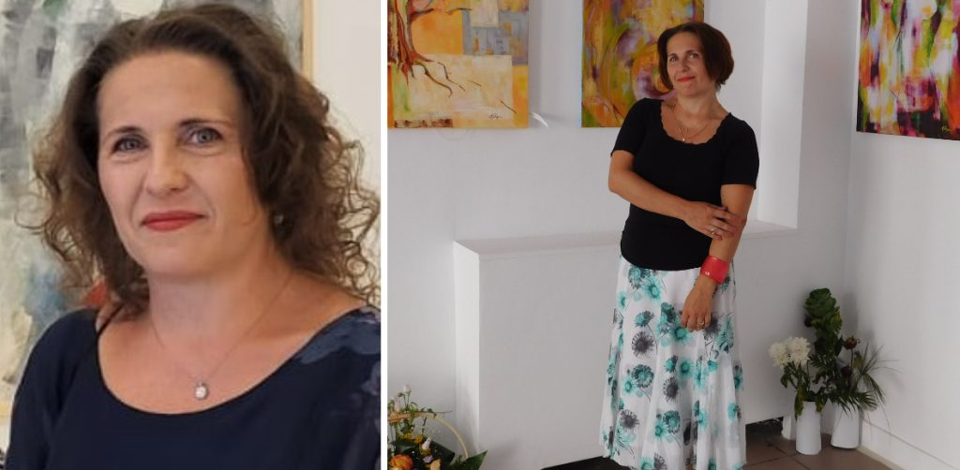

Unveiling the Artistry of Angelica Mirela Pagu: A Visionary Creator
/ Art & Culture / By weadmin
Nestled in the vibrant city of Iasi, Romania, lives and thrives a creative soul like no other – Angelica Mirela Pagu. A name that resonates within the artistic circles, Angelica is not just a visual artist; she is a phenomenon that transcends conventional boundaries. With an illustrious career spanning over two decades, Angelica’s artistic journey is a symphony of colors, emotions, and a testament to the power of creation.
Angelica Mirela Pagu stands proudly as a full-fledged member of The Union of Fine Artists from Romania, a prestigious affiliation that speaks volumes about her artistic prowess. Her academic journey is marked by dedication and excellence, with a bachelor’s degree from the esteemed “George Enescu” Art University in Iasi. Specializing in Decoration and Design, she continued to conquer new heights by obtaining a master’s degree in Sculpture from the same revered institution.

A Multifaceted Maestro
Angelica’s artistic identity is a tapestry woven with intricate threads of versatility and ingenuity. Her portfolio boasts an impressive array of achievements, including participation in over 60 group exhibitions and the spotlight of 14 solo shows. Her talent has not only been recognized but celebrated, with more than 30 awards adorning her name both within Romania and on the international stage.

Art as Catharsis: Angelica’s Vision
The heart of Angelica’s creations lies in her unique ability to transmute reality, emotions, and the kaleidoscope of human thought into a fantastical realm. Her artworks serve as a cathartic release, a liberation of feelings, and an exploration of our contemporary world’s complexities. With strokes of her brush, she transports us into a dimension where anxiety and alienation dissipate, making way for joy, beauty, and serenity.

Creating a New World
Angelica Mirela Pagu believes in the profound impact of art on our perceptions. She advocates for the creation of a new world, one that takes shape within our minds and finds expression in our artistic endeavors. Through her work, she not only envisions this alternate reality but also shares it with the world, inviting others to partake in her unique vision.

An Artistic Alchemist
Attempting to encapsulate the essence of Angelica Mirela Pagu’s artistry is a challenge that demands a deep understanding of her craft. Her artworks are more than just paintings; they are the culmination of intricate concepts and meticulously employed techniques. These creations are infused with her emotions, translated into articulated structures that captivate the beholder’s senses.

An Evocative Legacy
Angelica’s art is a synthesis of the known and the unknown, a harmonious blend that defies conventions. It emanates both spontaneity and rationality, inviting viewers to participate in her visual journey. Every stroke, every hue, and every form is a testament to her stored visual memories, transformed into enduring legacies that resonate through time.
In the realm of art, Angelica Mirela Pagu stands as an illustrious figure, an artist whose creations transcend the canvas and speak to the very essence of human experience. Her journey continues to inspire, her art continues to evolve, and her legacy continues to enrich the world with beauty and meaning.

