

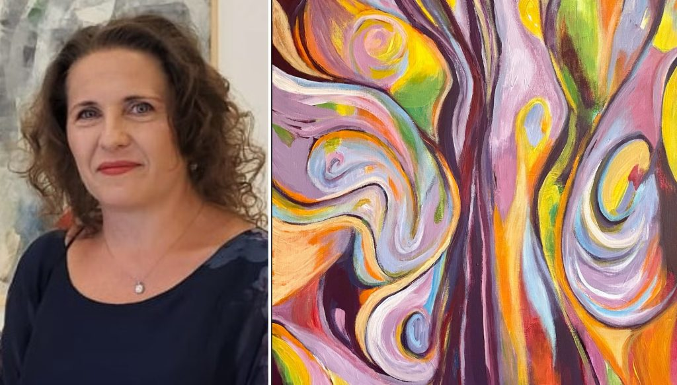

Angelica Mirela Pagu: A Transformative Force in Contemporary Art
/ Articles / By Editor
Angelica Mirela Pagu is a prominent member of the Union of Plastic Artists from Romania, Iasi Branch, where she is actively involved in the painting section. Her academic journey is rich and diverse, with significant qualifications that reflect her commitment to the arts. She graduated from the University of Art “G. Enescu” in Iasi, where she obtained her degree in Fine, Decorative, and Design Arts in 2014. Continuing her pursuit of knowledge, she earned a Master’s degree in Sculpture from the same institution in 2016, and previously completed her studies in painting at the School of Arts in Iasi in 2002. In addition, Angelica graduated from the University of Medicine and Pharmacy “Gr. T. Popa Iasi” in 1995, highlighting her multifaceted talents and interests.
Over the years, Angelica has achieved remarkable recognition, receiving 42 awards and distinctions that underline her impact within the art community. Notable accolades include the Certificate of Excellence at the Panorama International Arts Festival 2023, the Prize for Popularity at the ARTE International Festival in 2021, and multiple awards for her painting in the Portrait-Self-Portrait exhibitions held in Iasi from 2018 to 2020. Her contributions to the arts have also been recognized with a nomination diploma at the International Competition “Empaths on both sides of the Prut” in 2019, and she received the title of excellence for promoting the arts at the Barlad Plastic Competition in 2016.
Angelica’s artistic expression is further amplified by her extensive participation in exhibitions. She has showcased her work in 105 group exhibitions, including prominent events such as the Panorama International Arts Festival PIAF 2023, the Annual exhibition of the UAPR Sibiu branch at the Brukental Museum in 2022, and the International Fine Art Biennale N. Tonitza in 2022 and 2023. Her personal exhibitions, such as “3 for Art” at the G. Pallady Art Gallery from 2021 to 2023, “Labyrinth” in 2020, and “Angel Windows” in 2018, have captivated audiences and reinforced her status as an innovative artist.
In addition to her exhibitions, Angelica has made notable contributions to the field through various other achievements. She designed the cover for the medical work “Physiology and Pathophysiology for Medical Students” by Dr. Robert Ioan Mihaila in 2023, and penned an article titled “Amici picturae” in the volume Dimitrie Cantemir: Encyclopedic Spirit in the European Space in 2021. Her works have been featured in several albums and magazines, further showcasing her versatility and dedication to the arts.
Angelica’s artistic creations, primarily executed in mixed techniques with overlapping structures, utilize acrylic colors on canvas to convey deep emotional states. Her latest works are inspired by the theme of “Fire,” symbolizing transformation and inner restlessness. Through the dynamic interplay of colors—ranging from strong, vibrant hues to earthy tones—she captures the essence of both personal and collective metamorphosis. The titles of her works, such as “Vibration,” “Transformation,” and “Dynamic Structures,” embody the essence of this creative journey, reflecting the power of fire to melt and reshape forms, ultimately presenting new possibilities for life and expression.
Angelica Mirela Pagu’s art transcends mere aesthetics; it serves as a reflection of the transformative forces inherent in the human experience. Her commitment to exploring complex themes through her work resonates with audiences, establishing her as a significant figure in contemporary art

